The Classical Academy (TCA) of Sarasota proposes to develop a large, private school campus with up to 1,310 students by 2028 (K-12) at the 41.2 acres at the existing Grace Church site at 8000 Bee Ridge Road. Future numbers beyond that are unknown. The parcel is not zoned for this use, so TCA is applying for a Special Exception (variance) to existing zoning. An application to the County is anticipated in early March.
TCA wants to move from its Fruitville location into the Bee Ridge property and start school in August 2023. Based on preliminary information, this campus could become one of the largest school campuses in Sarasota County, behind Riverview and Sarasota High Schools.
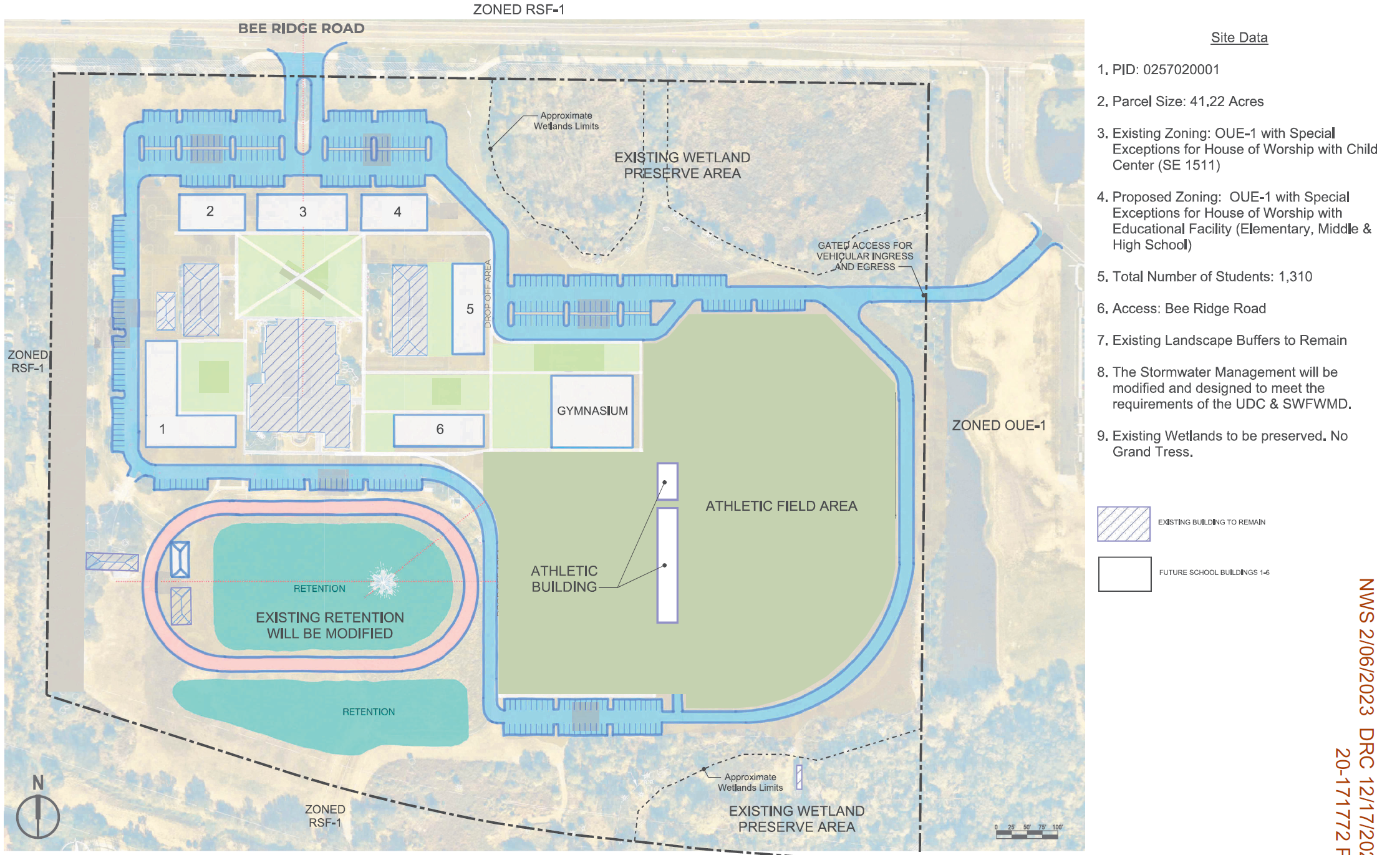
The site depiction above was shared at the applicant’s Neighborhood Workshop on February 6, 2022. For orientation, note that Bee Ridge Road runs horizontally at the top of the graphic. Note that only a “generic green” Athletic Field Area is shown. Residents are concerned – and confused – as to why more detailed site development plans have not been shared to date.
At the workshop, Genesis also described a new connecting road from the Grace Church parcel into the adjacent Bayside Church property to the east – announcing school intentions to potentially use this property as an entrance/exit point and for parking lot spaces. The Bayside entrance/exit lies directly across the street from The Hammocks front entrance. Because of this “use,” it is foreseeably-speculated that TCA may intend to eventually purchase and expand into the Bayside Church parcel.
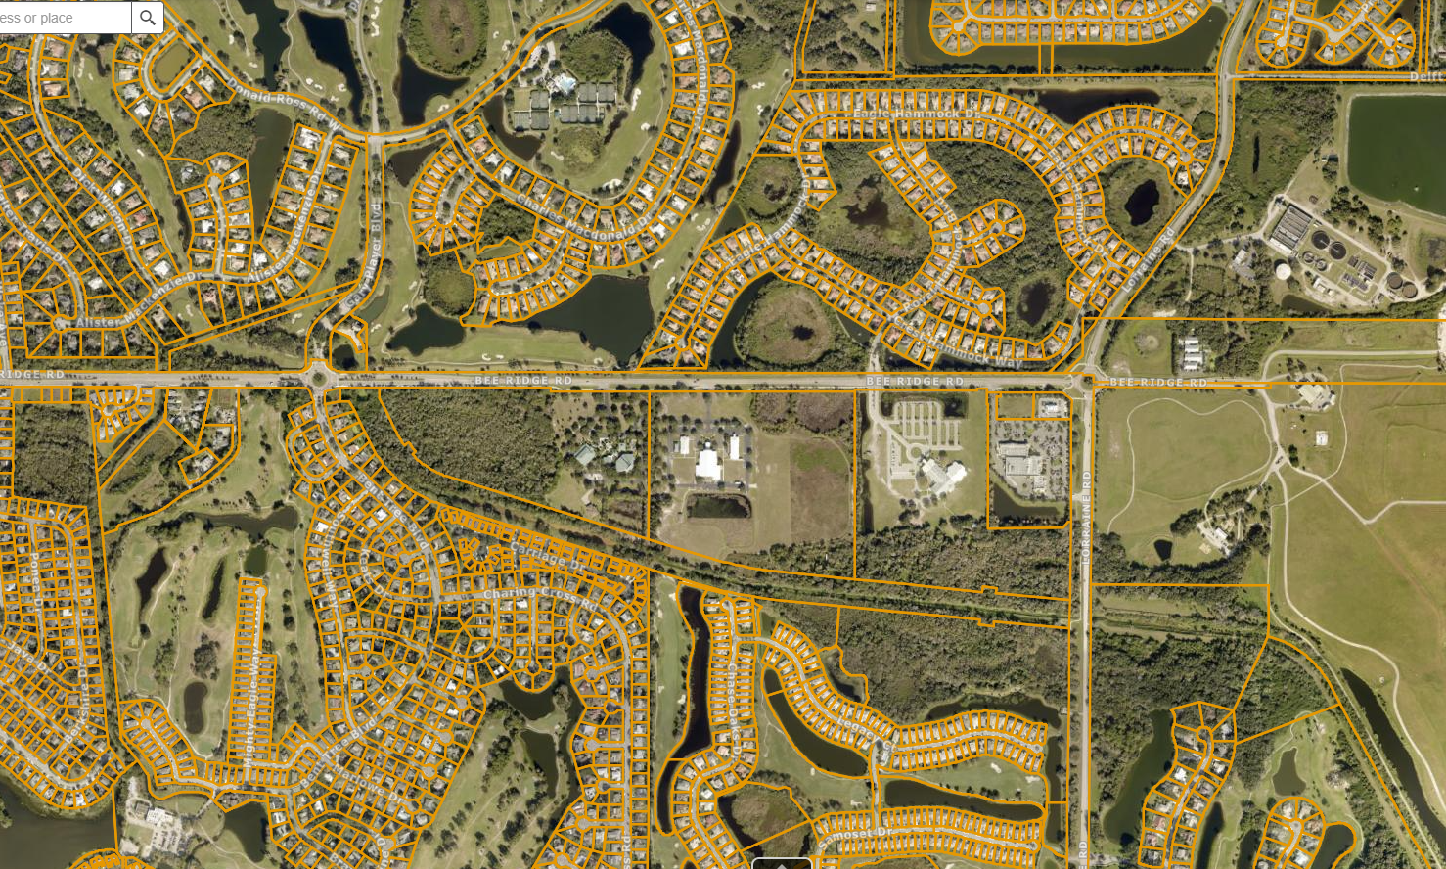
Lorraine Road
Bee Ridge Road
Proposed driveway into, and USE of Bayside Church access point and parking. (Exact area unknown)
Possible future TCA Campus expansion?
Proposed TCA development
Of Grace Church parcel
In 2021 and 2022, TCA submitted applications to the county to develop a school site along Fruitville Road, just north of the Founder’s Club. Below is a depiction of that site development plan.
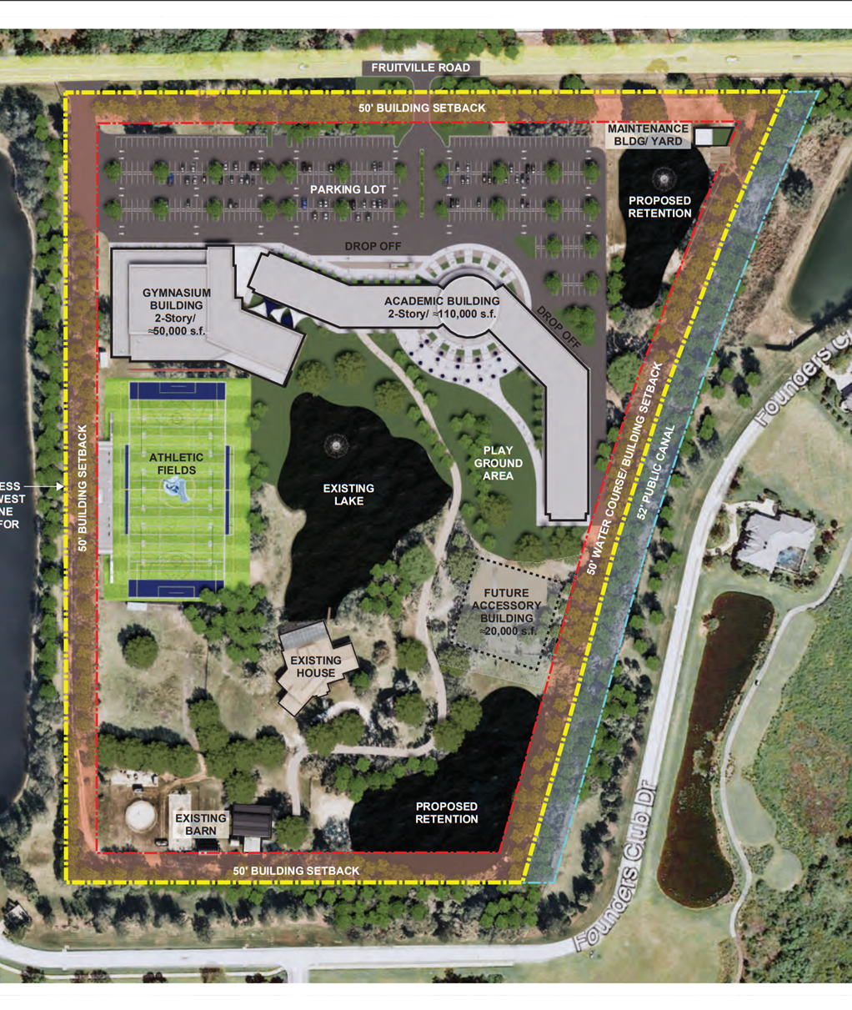
Note how the proposed Fruitville site details are clearly and crisply presented. For example – a future football/soccer stadium is depicted, with grandstands and a press box. New buildings, parking lots, trees, and setbacks are shown. Contrast that detailed depiction to the vague and undetailed Grace Church site plan shared on February 6th. Why was this level of detail not depicted on the Grace Church site plan for the February 6th workshop?
Shown just below is a depiction of the proposed athletic field from the 2021/2022 TCA county application for the Fruitville site. Note the tall stadium lights and press box.

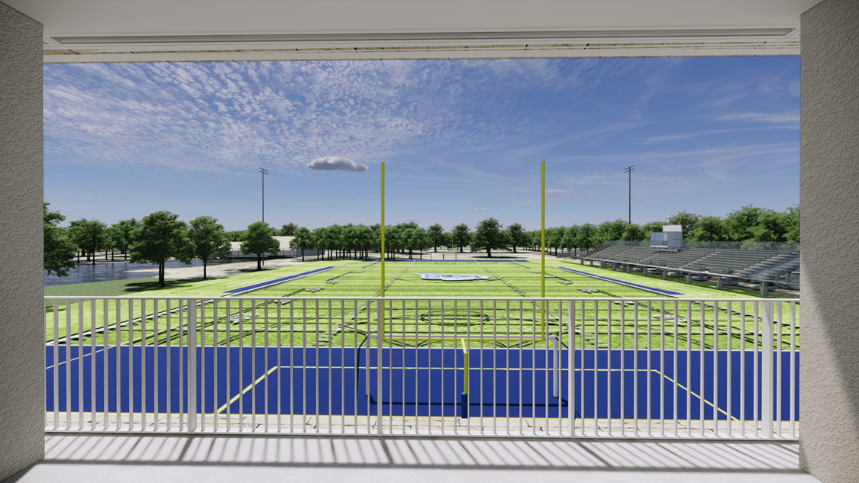

At that workshop, some residents, who had already viewed the Fruitville application, asked whether TCA intended to build a stadium complex with lights and amplified public address system.
- TCA/Genesis confirmed that a stadium field is the intention – plus a track and field.
- Residents then raised their concerns about amplified noise and the night-time impact of stadium lights.
- Residents asked for an estimate of the number of games and other musical or concert events that would take place at the stadium.
- It was also asked whether 3rd party athletic clubs or organizations would be allowed to use the fields – and the answer was: YES.
Thus, residents are understandably concerned that they may have to deal with noise and light impacts from the stadium almost every night and every weekend. Amplified noise is known to travel for long distances – and certain atmospheric conditions in the morning and evening extend that distance even further. In the same manner, direct and refracted light (skyglow) from stadium lights can also impact residents at a considerable distance. These annoyances disrupt the peaceful enjoyment of our property. A question arose about the need for sound barriers or noise walls, but it was quickly (and not credibly) dismissed as not needed. Significant discussion also ensued about long-term traffic impacts and disruptions.
TCA’s website maintains a Capital Campaign section, which hopes to raise funds for a school campus. One page is entitled “Naming Opportunities,” which provides the following list:
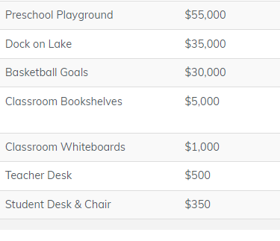
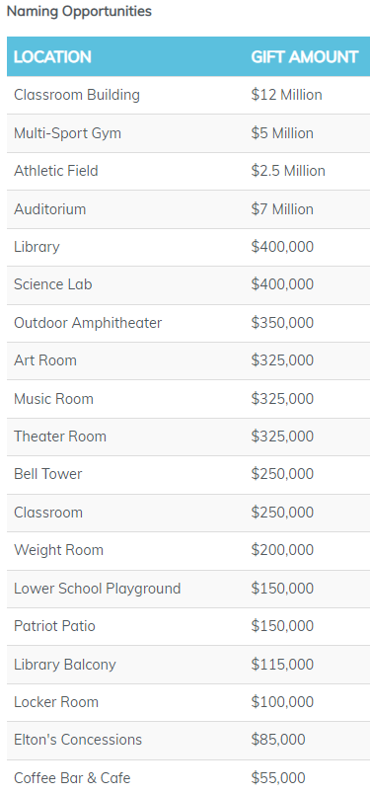

Numerous of these “intended” campus features have not been presented to residents, yet several potentially cause impacts by their existence:
$350k Outdoor Amphitheater – noise and light impacts?
$7M Auditorium – nighttime plays and concerts? Traffic?
$250k Bell tower – noise annoyance during day and night?

Summary:
Per county ordinance, the burden falls on the petitioner to provide information necessary to demonstrate that the grant of special exception… will be in harmony with… and not injurious to the neighborhood or to adjoining properties. Furthermore – and per the intent of Sarasota ordinance: East-End citizens expect and deserve an open and honest public discussion of all development intentions – with detailed plans, analysis, and meaningful measures to first minimize - and then mitigate the anticipated impacts of noise, night-light (skyglow) impacts, traffic jams/congestion – and the associated degradation of air quality. Extolling from the TCA’s core Habit of Courtesy value, this means “behavior marked by respect for and consideration of others.” In that same regard, affected residents want responsible development that legitimately and respectfully considers impacts to our pre-existing and peaceful neighborhoods.

The information provided on http://SEERD.org is for general information purposes only. Any information on the Site is provided in good faith, however we make no representation or warranty of any kind, express or implied, regarding the accuracy, adequacy, validity, reliability, availability, or completeness of any information on the Site. UNDER NO CIRCUMSTANCES SHALL WE HAVE ANY LIABILITY TO ANY PARTY FOR ANY LOSS OR DAMAGE OF ANY KIND INCURRED AS A RESULT OF THE USE OF THE WEBSITE OR RELIANCE ON ANY INFORMATION PROVIDED ON THE SITE. USE OF THE SITE AND RELIANCE ON ANY INFORMATION ON THE SITE IS SOLELY AT THE USER'S OWN RISK.

